FACILITATOR GUIDE

COMPUTERS, DEVICES AND COMPUTING SYSTEMS

Module Code | 252901001-KM-07
NQF Level | 4
Credits | 6
Curriculum Code | 252901001
Qualification Title | Occupational Certificate: Cybersecurity Analyst
SAQA QUAL ID | 118986

Name
Contact Address
Telephone (H)
Telephone (W)
Facsimile
Cellular
E-mail

Note to the learner
This Learner Guide provides a comprehensive overview of the module. It is designed to improve the skills and knowledge of learners, and thus enabling them to effectively and efficiently complete specific tasks.
Entry Requirements

- NQF 4
Provider Accreditation Requirements for the Knowledge Module

Physical Requirements
- The provider must have lesson plans and structured learning material or provide learners with access to structured learning material that addresses all the topics in all the knowledge modules as well as the applied knowledge in the practical skills.
- QCTO/ MICT SETA requirements

Human Resource Requirements:
- Lecturer/learner ratio of 1:20 (Maximum)
- Qualification of lecturer (SME):
    - NQF 6 in industry recognised qualifications with 1 years’ experience in the IT industry
    - CYBERSECURITY vendor certification
- Assessors and moderators: accredited by the MICT SETA
Legal Requirements
- Legal (product) licences to use the software for learning and training
- OHS compliance certificate
- Ethical clearance (where necessary)
Module Purpose
The main focus of the learning in this knowledge module is to build an understanding of what computers can do, and the processes that make them function in terms of the four major parts: the input, output, CPU (central processing unit), and memory. It gives an overview of networks and connectivity

Topic elements to be covered include
The learning will enable learners to demonstrate an understanding of:
- KM-07-KT01: Problem solving skills for IT Professionals
- KM-07-KT02: Techniques for safety
- KM-07-KT03: System components
- KM-07-KT04: Motherboards
- KM-07-KT05: Processors
- KM-07-KT06: Memory
- KM-07-KT07: BIOS and CMOS
- KM-07-KT08: Hard drives and storage devices
- KM-07-KT09: Power supplies and voltage
- KM-07-KT10: Ports, cables, and connectors
- KM-07-KT11: Input and output devices
- KM-07-KT12: Installing and managing printers
- KM-07-KT13: Mobile devices, multimedia, and laptop computers
- KM-07-KT14: Preventative maintenance
- KM-07-KT15: Troubleshooting procedures
- KM-07-KT16: Operating systems
- KM-07-KT17: Managing files
- KM-07-KT18: Applications utility, troubleshooting, and optimization
- KM-07-KT19: Configuring device drivers
- KM-07-KT20: Networking and wireless connections
- KM-07-KT21: Recovery
- KM-07-KT22: Cloud computing
- KM-07-KT23: Security fundamentals
- KM-07-KT24: Introduction to applications

Venue, Date and Time:
Consult your facilitator should there be any changes to the venue, date and/or time.
Refer to your timetable
Assessments

The only way to establish whether you are competent and have accomplished the learning outcomes is through continuous assessments. This assessment process involves interpreting evidence about your ability to perform certain tasks. You will be required to perform certain procedures and tasks during the training programmer and will be assessed on them to certify your competence.

This module includes assessments in the form of self-evaluations/activities and exercises. The exercises, activities and self-assessments will be done in pairs, groups or on your own. These exercises/activities or self-assessments (Learner workbook) must be handed to the facilitator. It will be added to your portfolio of evidence, which will be proof signed by your facilitator that you have successfully performed these tasks.

Listen carefully to the instructions of the facilitator and do the given activities in the time given to you.

KM-07-KT01: Problem solving skills for IT Professionals
Question
1
Explain problem-solving steps and the application thereof
CHALLENGES FACING IT PROFESSIONALS

- Workload
- Cybersecurity
- Skills gaps
- Digital transformation
- Cloud computing
- Hiring
- Budget
- Leadership support
- Analytics and data management
- Automation
- Project management
- Career growth
1. WORKLOAD
Both IT staff and decision-makers are overwhelmed with work demands. It’s sort of a chicken and egg scenario—decision-makers are using increasing workloads as an excuse not to authorize training, and staff are struggling to complete assignments because they lack the proper skills. Either way, time that was previously designated toward skills development is now being used to catch up on an increasing backlog of work.
Workload concerns are the highest they’ve been in the history of our IT Skills and Salary Report. It’s the number one training inhibitor, as IT professionals believe mounting workloads limit the amount of time they can spend out of office or in a training course.
Better manager oversight and strategy is required to address this issue. Automation may also be a solution as a means to reduce time-consuming tasks that are not high priority.
2. CYBERSECURITY
The cybersecurity challenge is two-fold:
- Cyberattacks are growing in size and sophistication
- Millions of cybersecurity jobs remain unfilled
Organizations cannot take IT security lightly. An analysis of worldwide identity and access management by the International Data Corporation (IDC) revealed that 55% of consumers would switch platforms or providers due to the threat of a data breach, and 78% would switch if a breach impacted them directly.¹ Customers aren’t willing to put their data at risk.
The problem is there aren’t enough IT professionals with cybersecurity expertise. Forty percent of IT decision-makers say they have cybersecurity skills gaps on their teams. It’s also identified as the most challenging hiring area in IT.
There isn’t an immediate solution to this problem, but a long-term fix is to build your cyber workforce from the inside. Invest in cybersecurity training and upskill your current staff. Hiring and outsourcing isn’t always a viable (or cheap) solution. Current IT professionals who know the industry are more apt to transition into successful cybersecurity professionals.
3. SKILLS GAPS
Over 80% of North American IT departments have skills gaps. Globally, IT skills gaps have increased by 155% in three years. They can no longer be ignored, especially as a lack of necessary skills can be credited for increased employee stress, development and deployment delays, and increased operating costs.
According to IT decision-makers, skills gaps will cost employers up to 416 hours and over R22,000 per employee, per year. You would think those numbers would motivate organizations to increase skill development opportunities for employees, but that isn’t always the case. Less than 60% of decision-makers say their organizations offer formal training for technical employees, down one percent from the previous year. This tells us that organizations aren’t serious enough about skill development.
The time to act is now—skills gaps will only grow and further debilitate IT departments unless actions are taken. Strategic and continual training is the antidote. That’s the good news. The uphill battle is conveying the value to management and securing budget to ensure employees receive continual training. IT professionals need better support. If organizations do not invest in their employees’ skills now, they will pay for it down the road.
4. DIGITAL TRANSFORMATION
Digital transformation is latest disrupter. It has led to technology no longer providing a sustained competitive advantage. It now plays a supporting role to people with the right skills. Expertise is needed now more than ever to manage and implement all of the new technologies.
But it’s not that simple. As discussed above, IT departments are suffering from gaps in critical skills areas such as cybersecurity, cloud computing and DevOps. Even IT professionals who are offered professional development opportunities are struggling to keep up. The rate of technological change is outpacing training.
IT professionals and departments are falling behind—they are failing to meet business objectives and seize market opportunities. While continual training is part of the equation, prioritizing skill needs is even more of a priority. That’s why we created the Skills Development Index™ to help IT professionals rank their most critical skill needs and determine which type of training to pursue. Informal training has its merits, especially when on-the-fly knowledge must be acquired, but when a high-value project is on the line, more formal learning is the better option.
5. CLOUD COMPUTING
Cloud is the top investment area worldwide for IT departments. Organizations require an infusion of cloud skills to match their monetary investment in cloud platforms. Much like cybersecurity, cloud professionals are in high demand and short supply. According to IT decision-makers, cloud computing is the second most challenging hiring area in the world.
The opportunities of cloud computing are impossible to ignore. Cloud is the ultimate enabler, opening new channels of revenue by leveraging technologies like artificial intelligence (AI) and the Internet of Things (IoT). But professionals are needed to capitalize on this technology, and currently, there aren’t enough of them.
Despite the worker shortage, organizations are all-in on cloud solutions. In fact, more than 50% of organizations use more than one cloud provider.² It’s not unique for an organization to require cloud skills in AWS, Microsoft Azure and Google Cloud. And generic cloud computing expertise isn’t enough, especially if you’re an engineer or architect. It’s imperative that cloud professionals have current skill sets and train on the platforms they engage with regularly.
6. HIRING
Talent recruitment and retention is a major challenge for IT leaders—50% are currently struggling in the area. Only seven percent of IT decision-makers say that hiring has been easy.
Managers hoping to hire their way out of a skills gap problem have been dealt a dose of reality, as key positions like cloud computing and cybersecurity are the most difficult to fill.
One potential solution to this quandary is degree deflation, which is a conscientious effort to focus on skills rather than a college degree during the hiring process. A bachelor’s degree is not necessarily an indicator of abilities, especially in tech. Recent training and certifications better illustrate what a professional is capable of right now.
7. BUDGET
A lack of budget and resources is another major concern for both IT staff and decision-makers. The open-field sections of our IT Skills and Salary Survey are littered with criticisms about budget constraints. IT professionals want to train but their requests aren’t always approved by management.
Budget is often the major roadblock impeding professional development and hiring. IT departments need to ensure they are communicating the right messages to organizational leadership to help them understand the value of ongoing training. Here’s a place to start: revenue growth, low employee turnover and new product development are signs of a skilled workforce.
There are a number of ways to maximize a constrained budget. Prepayments and special offers are options to save on training. Lock in a discounted rate for a full year, or save a certain percentage on individual courses. Also, make sure you are aware of any training credits your company may have. They are typically issued by tech providers as a way to help drive value for a particular investment. Global Knowledge accepts training credits and vouchers as payment for courses. Know your balance and know when they expire.

KM-07-KT02: Techniques for safety 5%
Question
2
Describe the OSHA electrical safety standard 1926.431
This standard relates to equipment upkeep and maintenance. If employers don't inspect, repair, and upgrade their machinery, that can lead to failure and electrical injury or death. This specific standard refers to the construction industry, but the recommendations work well for all job sites. Some elements of standard 1926.431 include:
- Explosion-Proofing- Employers must maintain equipment so that there is little to no risk of an explosion due to electrical malfunction.
- Dust Proofing- Dust can get into machinery and cause various problems, both mechanical and electrical. Employers must protect all gear from dust-related incidents that could lead to an explosion or electrical arc.
- General Maintenance and Upkeep- Employers and employees must monitor equipment and machinery to watch out for loose screws, gaskets, and other pieces that may interfere with dust and explosion prevention.
- Reporting and Repair- If a worker spots any issues with machinery, they have to report to a supervisor immediately. Once a report is filed, the employer must stop using the circuit until the problem is fixed.
OSHA Electrical Safety Standard 1926.416(a)(3)
As we'll discuss in the next section regarding electrical safety precautions, workers need to know where circuits are at all times and how to shut them off. Typically, the best way to avoid electrical injuries or fatalities is to stop the flow of power from the source. This outlines various requirements for employers, such as labelling circuits with easy-to-spot signage, warning employees before they start work in an area with a live circuit, and locating and inspecting circuits regularly.
8 General Safety Tips for Working with Electrical Wires
Before your employees start working with or around electrical wires, they should be trained in proper safety techniques and precautions. Here are some generalized tips that can help prevent a disaster.
1. Make a Plan
The best way to avoid harm is to draft a project plan beforehand. During the planning phase, workers can assess the equipment and environment to spot any potential hazards. Planning can ensure that workers will use the proper PPE and IPE during the job and that they'll know where the correct circuit is for shutting off power.

KM-07-KT03: System components 5%
Question
3
Describe various types of system components
What is a Processor?
Definition: The processor is a chip or a logical circuit that responds and processes the basic instructions to drive a particular computer. The main functions of the processor are fetching, decoding, executing, and write back the operations of an instruction. The processor is also called the brain of any system which incorporates computers, laptops, smartphones, embedded systems, etc. The ALU (Arithmetic Logic Unit) and CU (Control Unit) are the two parts of the processors. The Arithmetic Logic Unit performs all mathematical operations such as additions, multiplications, subtractions, divisions, etc and the control unit works like traffic police, it manages the command or the operation of the instructions. The processor communicates with the other components also they are input/output devices and memory/storage devices.
Types of Processors
There are different types of processors in the embedded system which include the following.
General Purpose Processor
There are five types of general-purpose processors they are, Microcontroller, Microprocessor, Embedded Processor, DSP and Media Processor.
Microprocessor
The general-purpose processors are represented by the microprocessor in embedded systems. There are different varieties of microprocessors available in the market from different companies. The microprocessor is also a general-purpose processor that consists of a control unit, ALU, a bunch of registers also called scratchpad registers, control registers and status registers.

KM-07-KT04: Motherboards 5%

Question
4
Explain the uses of the following
- Motherboards
- Primary components

Components of Motherboard
In the below section, some of the important components of the motherboard are defined below:
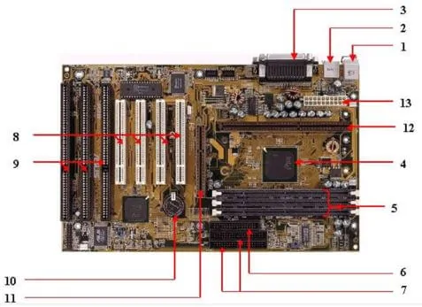
1. Keyboard and mouse
There are mainly 2 types of mouse and keyboard connectors. The first connector is known as PS/2 & the second connector is known as USB.
2. Universal Serial Bus (USB)
The USB port is used for connecting the computer system. In the computer system, there is various type of devices that are connected with the USB port like keyboard, mouse, camera, scanner, printers, and another device. The main use of a USB port is to connect the peripheral devices and computer motherboards. The peripheral device connected to the computer system can be inserted or remove without system restarts that can be the main advantage of a USB port.
3. Parallel port
The old printers that are used in past use the parallel port to connect with the computer system. In the parallel port, multiple wires are used to send or receive multiple bits of the data in a single instance. On the other hand, serial ports use only one wire at a time. In the parallel port, 25 pins female DB type connector is used.
4. CPU chip
The central processing unit is the processor that controls all the functions of the computer system. The overall flow of task and functions are controlled by the central processing unit. For the computer system, the central processing unit is called the brain of the computer system.
5. RAM slots
The RAM slots are used for connecting the RAM (memory) in the computer system. In the general computer system, there are mainly two RAM slots but sometimes there can be four-plus slots in the motherboard to increase the memory of the computer system.
6. Floppy Controller
The older motherboard chip contains a 34-pin type ribbon cable for connecting the computer system with a floppy drive. In this ribbon cable, one end is directly connected with the computer system and one end is connected with the motherboard.
7. IDE controller
The integrated drive electronics are also known as ATA or Parallel ATA. The IDE is the type of component that issued for hard drive control. In today’s computer system, the IDE controller supports is not supported.
8. PCI slot
The full form of PCI is a peripheral component interface. The PCI slot is mainly used to insert the expansion cards on the computer. The other PCI devices can also be connected like a sound card, network card, video, card, modems, and other device3s. In today’s computer system support for PCI expansion slots are not there.
9. ISA slot
Industry-standard architecture (ISA) is defined as standard architecture for expansion bus. The ISA slot issued for connecting input devices and modems.
10. CMOS Battery
The CMOS battery is used for storing the BIOS settings on the motherboard. The CMOS battery is also capable of storing the time and data in it.
11. AGP slot
AGP (Accelerated Graphics slot) is a type of computer slot that is used for attaching the video card to the system. This slot is a high-speed slot so that data transfer can be done at high speed.
12. CPU slot
The CPU slot is a type of port that is used to connect the central processing unit to the motherboard of the computer system.
13. Power supply slot
The power supply slot is used for providing the electric supply to the computer system so that it can start and perform its functions. The total power supply given to the system is around 110 ac power. In the power supply type connector, there are a total of 20-pins that are used to maintain the power supply to the computer system.
Factors of Motherboard
The main form factor for the motherboard is size and shape. The other factors are physical layout, mounting holes, and board organization.
In the below section, some of the form factors are mentioned below:
1. ATX
In this type, the standard locations were defined for mouse, keyboard, input/output devices, video connectors, and other devices. In the year 1990, the ATX form factor was developed. The expansion slot given new location as in this form factor expansion slot were given separate space so that they can be connected with the motherboard.

KM-07-KT05: Processors 5%
Question
5
Outline the uses of processers
Processors
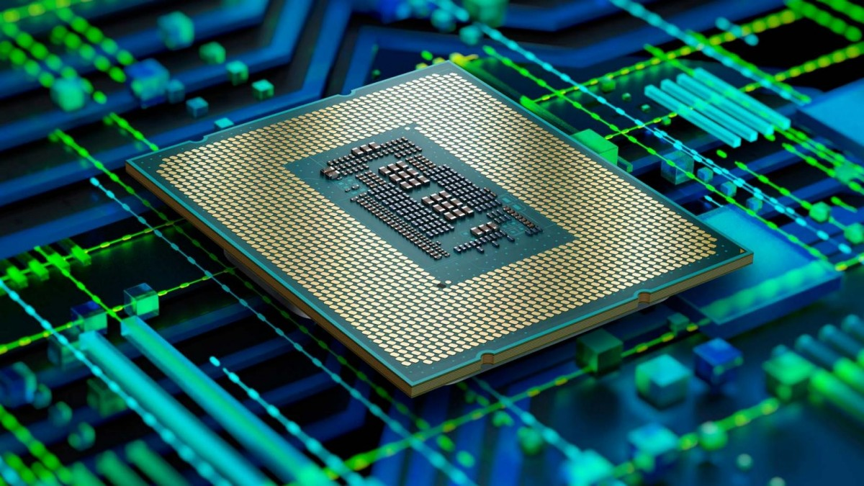
The processor is defined as a logic circuit or simple chip which reacts to fundamental instructions and input processes to operate the computer. The important purposes of a processor are getting, decoding, processing, executing and writing back as feedback to the instructions of the chip. The processor is termed as the brain of any electronic systems that incorporate into a laptop, computers, smartphones, and embedded systems. The control unit and arithmetic logic unit are the two significant components of the processors.
The logic functions can be addition, multiplication, subtraction and division whereas the control unit manages the traffic flow which follows the operation or command according to the input instruction. This processor interacts with the neighbouring component which can be their output, input, storage and memory components.
Different Types of Processors
The different types of processors are microprocessor, microcontroller, embedded processor, digital signal processor and the processors can be varied according to the devices. The important elements of the CPU are labelled as heart elements of the processor and system. The control unit activates, fetches, and execute the input instructions. The processor can be embedded in a microprocessor and comprise of unit IC chip. But some devices are based on multi-core processors. It comprises one or more CPU. It is a typical tiny component with pins embedded on the motherboard. It can also be linked to motherboard with fan and heat sink to disperse the produced heat.

KM-07-KT06: Memory 5%

Question
6
Describe the purpose of memory and how it relates to computer components
What Are the Functions of Computer Memory?
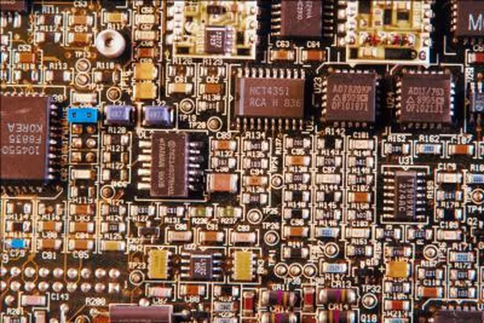
The basic function of computer memory is essentially to store data. Depending on the type of data it stores and the role it plays in computer operation, however, memory performs several different functions. Although all of these functions involve data storage, RAM, ROM, flash memory and hard drives each perform a different and necessary function to keep a computer and its peripherals working.
RAM
Random access memory (RAM) provides temporary application data storage. Instead of having to go back and find information on the hard drive every time a computer needs a piece of data, the computer temporarily stores frequently used files on RAM, making them easier to find. When the computer shuts down, all the data in RAM is erased or transferred to the hard drive, making room for new data when the computer begins operating again.
Hard Drive
A hard drive is core of a computer's data storage. It provides memory space for system and user files -- everything from your operating system to documents and images. In mechanical terms, a hard drive is a rotating disk treated with a magnetic coating, similar to the magnetic ribbons that store data on cassettes. A moving arm reads and copies data to and from the rotating disk, allowing you to open files from the hard disk or save new data.
Flash Memory
Flash memory, the common term for electronically erasable programmable read-only memory (EEPROM), is used in computer video game cards and to store some vital system information. Unlike other memory types that copy or erase data byte-by-byte, EEPROM can edit data in groups of bytes, making it a popular choice for devices like memory sticks and cameras where the data stored is constantly changing. Unlike hard drives, EEPROM does not require a fragile moving arm, prompting some computer manufacturers to move toward replacing hard disks with flash architecture, although the technology remains more expensive than hard disks.
ROM
Read-only memory (ROM) is used to store data that controls the most basic computer functionality, such as starting up, detecting peripherals and operating the computer fan. As the name suggests, the data cannot be edited by the system or users and, unlike RAM, the data stays recorded even when the computer is off. Like hard drives and flash memory, ROM is an example of non-volatile memory -- meaning that it remains in place when the power is off -- while RAM is considered volatile memory.

KM-07-KT07 : BIOS and CMOS 5%

Question
7
Describe the operation of BIOS and CMOS
What is BIOS?
As your PC’s most important startup program, BIOS, or Basic Input/Output System, is the built-in core processor software responsible for booting up your system.
Typically embedded into your computer as a motherboard chip, the BIOS functions as a catalyst for PC functionality action.
Programmed on an erasable, programmable, read-only memory (EPROM) chip, BIOS is stored on this memory chip which retains data when the power source is switched off. When the PC is powered back on, BIOS retrieves that same stored data.
The BIOS system is also responsible for managing data flow between your computer’s operating system and any attached devices including a hard drive, keyboard, video adapter, printer, or mouse.
Each time you power your PC on, BIOS runs through a process called Power-On Self Test, or POST, that determines whether your attached devices are operating correctly and are in their proper place.
Once all attachments are allocated and given the OK, your computer startup continues as usual and takes you to your load screen in a matter of seconds.
If BIOS detects any problems, an error screen will appear or a series of beep codes will sound, effectively indicating to you that something has gone wrong.
New developments in BIOS technology
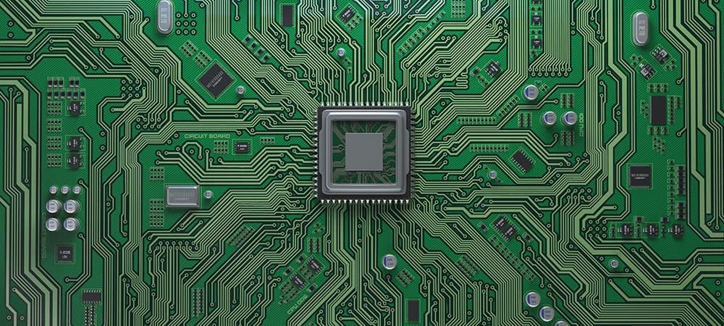
BIOS software has existed within computers since the 1980s and has made plenty of leaps and strides when it comes to efficiency and improvement. However, with the rapid speed of technological evolution, BIOS has become outdated and presents a number of roadblocks for today’s tech.
Newer PCs capable of handling several terabytes of storage prove to be too complex for weaker BIOS software. Limited to 16-bit processor modes and booting drives of 2.1TB or less, newer computers are usually equipped with 3TB drives or more.
Thus, the UEFI was born out of necessity for higher-powered booting. The new standard of BIOS accommodates the limitations the old BIOS system couldn’t work around. UEFI, or Unified Extended Firmware Interface Forum, can run in 32-bit or 64-bit modes and theoretically handle drives up to 9.4 zettabytes.
Not only is UEFI a BIOS replacement, but it also functions as a mini operating system that runs on top of your PC’s integrated firmware.
In essence, whether your computer is powered on by BIOS or UEFI, it is this software that you count on for fast boot times and proper processing functionality. Being able to access your PC’s BIOS allows you to perform regular maintenance for healthy computer upkeep.
What are the basic functions of BIOS?
Now that you understand what BIOS is, let’s dive into what it really does for your desktops, laptops, and tablets. BIOS’s functionality can be broken down into four key responsibilities.
1. POST
As we mentioned before, POST is an acronym for the Power-On Self Test that your PC runs through the moment you turn it on. POST tests the hardware of your PC and ensures that there is nothing out of order and no errors present with your operating system.
POST goes through everything from your keyboard and disk drive to your RAM speed in a computer and integrated ports. Should everything be in order, POST will continue as usual and allow your PC to boot normally.
If there is a detected error, BIOS will issue an error message that may come in the form of displayed text or a series of error-indicating beeps.
These beeps are always signals to certain messages, so if you happen to get this result, you will need to check out what it means for your computer’s hardware [1].

KM-08-KT08 : Hard drives and storage devices 5%

Question
8
Explain the features of hard drives and storage devices and components
What Does Hard Disk Drive (HDD) Mean?
A hard disk drive (HDD) is a non-volatile computer storage device containing magnetic disks or platters rotating at high speeds. It is a secondary storage device used to store data permanently, random access memory (RAM) being the primary memory device. Non-volatile means data is retained when the computer is turned off.A hard disk drive is also known as a hard drive.
Hard Disk Drive (HDD)
A hard drive fits inside a computer case and is firmly attached with the use of braces and screws to prevent it from being jarred as it spins. Typically, it spins at 5,400 to 15,000 RPM. The disk moves at an accelerated rate, allowing data to be accessed immediately. Most hard drives operate on high-speed interfaces using serial ATA (SATA) or serial attached technology. When the platters rotate, an arm with a read/write head extends across the platters. The arm writes new data to the platters and reads new data from them. Most hard drives use enhanced integrated drive electronics (EIDE) including cables and connectors to the motherboard. All data is stored magnetically, allowing information to be saved when power is shut off.
Hard drives need a read only memory (ROM) controller board to instruct the read/write heads how, when and where to move across the platters. Hard drives have disks stacked together and spin in unison. The read/write heads are controlled by an actuator, which magnetically reads from and writes to the platters. The read/write heads float on a film of air above the platters. Both sides of the platters are used to store data. Each side or surface of one disk is called a head, with each one divided into sectors and tracks. All tracks are the same distance from the centre of the disk. Collectively they comprise one cylinder. Data is written to a disk starting at the furthest track. The read/write heads move inward to the next cylinder once the first cylinder is filled.
A hard drive is divided into one of more partitions, which can be further divided into logical drives or volumes. Usually a master boot record (MBR) is found at the beginning of the hard drive and contains a table of partition information. Each logical drive contains a boot record, a file allocation table (FAT) and a root directory for the FAT file system.

KM-07-KT09: Power supplies and voltage 5%

Question
9
Explain power supply and the effect on system hardware and components
Redundant Power Supply vs Uninterruptible Power Supply (RPS vs UPS)

Have you ever seen redundant power supplies (RPS) in the servers or some switches, such as Cisco switches, HPE servers, etc.? What is the difference between RPS and ordinary power supply?
Maybe you know the meaning and application of RPS, but do you know UPS, the Unplugged power supply?
In this article, let’s discuss the difference between RPS and UPS.
Redundant power supply
The redundant power supply (RPS) is a kind of power supply used in the server. It is composed of two identical power supplies. The chip control power supply performs load balancing. When one power supply fails, the other power supply can take over its work immediately. Replace the power supply. Later, two power supplies work together. The redundant power supply is to achieve high availability of the server system. In addition to servers, disk array systems are also widely used.
The RPS power supply (Redundant Power System) is used as an external DC power supply for some switches.
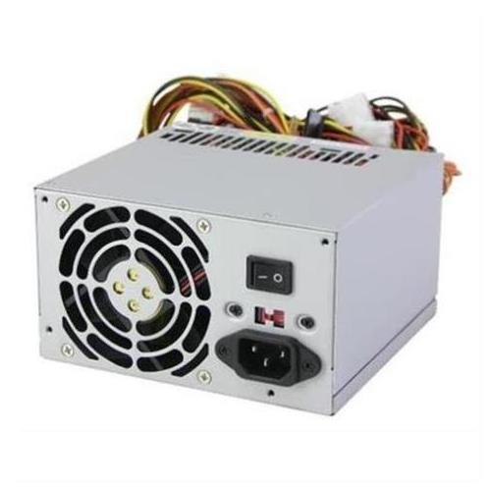
RPS can be used as a redundant power supply for switches or routers:
If the RPS and the power receiving equipment use the same AC power supply system, when the internal power supply of the power receiving equipment is abnormal, the RPS can continue to supply DC power to the failed equipment to ensure the continuous normal operation of the equipment;
If the RPS and the powered device use different AC power supply systems, DC power supply can continue to be provided when the external AC power supply of the powered device fails, ensuring continuous normal operation of the device.

KM-07-KT10: Ports, cables, and connectors 2%

Question
10
Demonstrate an understanding of ports, cables, and connectors and the effect of voltage
Characteristics of Ports
A port has the following characteristics −
- External devices are connected to a computer using cables and ports.
- Ports are slots on the motherboard into which a cable of external device is plugged in.
- Examples of external devices attached via ports are the mouse, keyboard, monitor, microphone, speakers, etc.
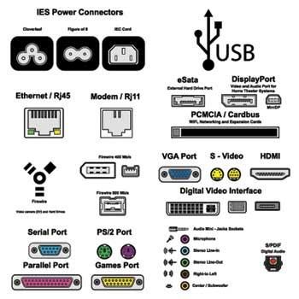
Let us now discuss a few important types of ports −
Serial Port
- Used for external modems and older computer mouse
- Two versions: 9 pin, 25 pin model
- Data travels at 115 kilobits per second
Parallel Port
- Used for scanners and printers
- Also called printer port
- 25 pin model
- IEEE 1284-compliant Centronics port
PS/2 Port
- Used for old computer keyboard and mouse
- Also called mouse port
- Most of the old computers provide two PS/2 port, each for the mouse and keyboard
- IEEE 1284-compliant Centronics port
Universal Serial Bus (or USB) Port
- It can connect all kinds of external USB devices such as external hard disk, printer, scanner, mouse, keyboard, etc.
- It was introduced in 1997.
- Most of the computers provide two USB ports as minimum.
- Data travels at 12 megabits per seconds.
- USB compliant devices can get power from a USB port.
VGA Port
- Connects monitor to a computer's video card.
- It has 15 holes.
- Similar to the serial port connector. However, serial port connector has pins, VGA port has holes.
Power Connector
- Three-pronged plug.
- Connects to the computer's power cable that plugs into a power bar or wall socket.
Firewire Port
- Transfers large amount of data at very fast speed.
- Connects camcorders and video equipment to the computer.
- Data travels at 400 to 800 megabits per seconds.
- Invented by Apple.
- It has three variants: 4-Pin FireWire 400 connector, 6-Pin FireWire 400 connector, and 9-Pin FireWire 800 connector.
Modem Port
- Connects a PC's modem to the telephone network.
Ethernet Port
- Connects to a network and high-speed Internet.
- Connects the network cable to a computer.
- This port resides on an Ethernet Card.
- Data travels at 10 megabits to 1000 megabits per seconds depending upon the network bandwidth.
Game Port
- Connect a joystick to a PC
- Now replaced by USB
Digital Video Interface, DVI port
- Connects Flat panel LCD monitor to the computer's high-end video graphic cards.
- Very popular among video card manufacturers.
Sockets
- Sockets connect the microphone and speakers to the sound card of the computer.

KM-07-KT11 : Input and output devices 3%

Question
11
Explain the functions of Input and output devices

List of Input Devices
Given below is the list of the most common input devices along with brief information about each of them.
- Keyboard
- A simple device comprising keys and each key denotes either an alphabet, number or number commands which can be given to a computer for various actions to be performed
- It has a modified version of typewriter keys
- The keyboard is an essential input device and computer and laptops both use keyboards to give commands to the computer
- Mouse
- It is also known as a pointing device
- Using mouse we can directly click on the various icons present on the system and open up various files and programs
- A mouse comprises 3 buttons on the top and one trackball at the bottom which helps in selecting and moving the mouse around, respectively
- In case of laptops, the touchpad is given as a replacement of the mouse which helps in the movement of the mouse pointer
- Joy Stick
- It is a device which comprises a stick which is attached at an angle to the base so that it can be moved and controlled
- Mostly used to control the movement in video games
- Apart from a computer system, a joystick is also used in the cockpit of an aeroplane, wheelchairs, cranes, trucks, etc. to operate them well
- Light Pen
- It is a wand-like looking device which can directly be moved over the device’s screen
- It is light-sensitive
- Used in conjunction with computer’s cathode ray tube
- Microphone
- Using a microphone, sound can be stored in a device in its digital form
- It converts sound into an electrical signal
- To record or reproduce a sound created using a microphone, it needs to be connected with an amplifier
- Scanner
- This device can scan images or text and convert it into a digital signal
- When we place any piece of a document on a scanner, it converts it into a digital signal and displays it on the computer screen
- Barcode Reader
- It is a kind of an optical scanner
- It can read bar codes
- A source of light is passed through a bar code, and its aspects and details are displayed on the screen
All the devices mentioned above are the most commonly used input devices. Several other such types of equipment are used in different fields which can be counted as an input device.
For the reference of candidates and to help them with the common computer-related terms, given below are links to difference between articles which will make these terms easily understandable:
What Are the Functions of Output Devices on a Computer?

Input devices are the hardware that give computers instructions. Output devices relay the response from the computer in the form of a visual response (monitor), sound (speakers) or media devices (CD or DVD drives). The purpose of these devices is to translate the machine's response to a usable form for the computer user.

KM-07-KT12: Installing and managing printers

Question
12
Demonstrate an understanding of types of printers, installing printers and dealing with problems
- Inkjet printers. Inkjet printers are the de-facto standard for consumer/home-use printers.
- Laser printers.
- All-in-one printers.
- Super tank printers.
- Dye-sublimation printers.
- Dot matrix printers.
- 3D printers.

KM-07-KT13: Mobile devices, multimedia, and laptop computers

Question
13
Outline tips to troubleshoot your internet connection
Tips to Troubleshoot Your Internet Connection
Have a full house working, gaming, streaming, and news binging, all at the same time? If you're experiencing lags, the problem might be on your end. Before you call your ISP, try these easy router tips to get back online.


With the proliferation of smart home devices, online gaming platforms, and video-streaming services, maintaining a strong internet connection is more important than ever. If you're experiencing lag while playing League of Legends, or it takes forever to download music, there's a good chance the problem is on your end and not an issue with your internet service provider (ISP). Before you schedule a service call with your cable company, check out our tips for troubleshooting your internet connection.

1. Try Another Device or Website
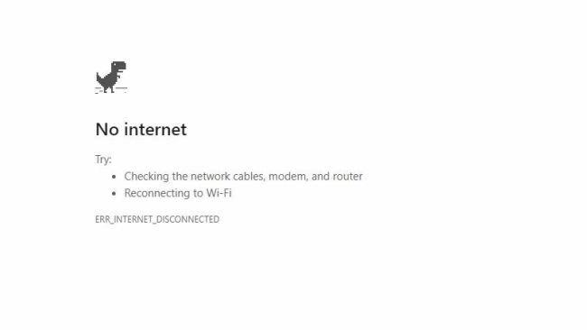
Start with the obvious: is the problem only happening on one device or all your devices? If your computer's having problems, see if your tablet or someone else's laptop can connect to the internet. If the problem only happens on one device, you can safely narrow the problem down to that particular machine.
If a specific website won't load, try another site. If you can visit other websites just fine, it's likely that the problem is with the website you're trying to visit, and you'll have to wait for them to fix things on their end. Try typing the website's address into downforeveryoneorjustme.com(Opens in a new window) or downdetector.com(Opens in a new window) to see if there's a known service outage.
If there is no known outage, it could be an issue with your browser's cache. You may want to try visiting the site in a private browsing window or from a different browser to see if that fixes the connection problem. And clear your browser's cache and cookies.

2. Check the Wi-Fi Settings
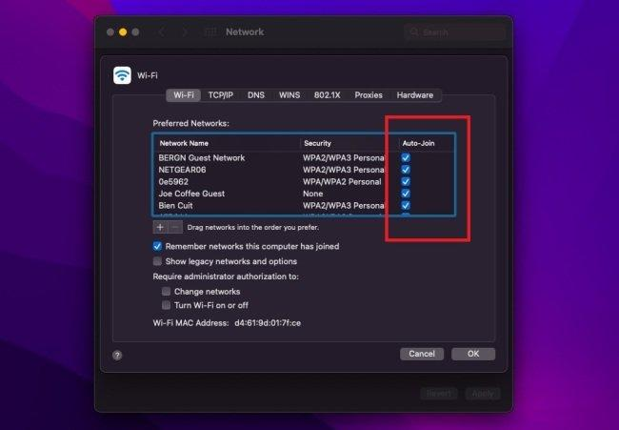
Check the Wi-Fi signal icon in the bottom-right corner of Windows and top-right corner in macOS. Click the icon and make sure you are connected to the proper SSID using the correct password. If not, you may be connecting to the wrong network by default. Windows users can change the connection priority or right-click a network and select Forget. On a Mac, open System Preferences > Network > Advanced and uncheck any unwanted networks under the Auto-Join column.
Troubleshooting
Do you know what to do if your screen goes blank? What if you can't seem to close an application, or can't hear any sound from your speakers? Whenever you have a problem with your computer, don't panic! There are many basic troubleshooting techniques you can use to fix issues like this. In this lesson, we'll show you some simple things to try when troubleshooting, as well as how to solve common problems you may encounter.
General tips to keep in mind
There are many different things that could cause a problem with your computer. No matter what's causing the issue, troubleshooting will always be a process of trial and error—in some cases, you may need to use several different approaches before you can find a solution; other problems may be easy to fix. We recommend starting by using the following tips.
- Write down your steps: Once you start troubleshooting, you may want to write down each step you take. This way, you'll be able to remember exactly what you've done and can avoid repeating the same mistakes. If you end up asking other people for help, it will be much easier if they know exactly what you've tried already.
- Take notes about error messages: If your computer gives you an error message, be sure to write down as much information as possible. You may be able to use this information later to find out if other people are having the same error.
- Always check the cables: If you're having trouble with a specific piece of computer hardware, such as your monitor or keyboard, an easy first step is to check all related cables to make sure they're properly connected.

KM-07-KT14: Preventative maintenance

Question
14
Explain the importance of preventative maintenance
Preventive maintenance (PM) is the regular and routine maintenance of equipment and assets in order to keep them running and prevent any costly unplanned downtime from unexpected equipment failure.
A successful maintenance strategy requires planning and scheduling maintenance of equipment before a problem occurs. A good preventive maintenance plan also involves keeping records of past inspections and the servicing of equipment.
Because of the complexity of maintaining a preventive maintenance schedule for a large amount of equipment, many companies use preventive maintenance software to organise their required preventive maintenance tasks.
What are the Types of Preventive Maintenance?
PM is used to anticipate and prevent the breakdown of equipment and should ideally be performed on all items of equipment to prevent age-related failure. Manufacturers often provide recommendations to maintain a piece of equipment but, generally speaking, there are three main types of preventive maintenance task:
Mandatory / Non-Mandatory Tasks
Mandatory tasks are those that must be performed as soon as they are due and will often include safety-critical checks. Non-mandatory tasks are still important, but can be delayed without resulting in a critical failure or performance reduction. A preventive maintenance checklist should split tasks into mandatory or non-mandatory.
Pyramiding / Non-Pyramiding Tasks
Pyramiding tasks occur when maintenance is set for a due date but is not completed and overlaps with a later scheduled maintenance. In this instance, should a new PM task become due, the previous one is cancelled. A cancellation should include a note to explain this and the new task should include the original due date to monitor how overdue the task is. Some companies prefer a non-pyramiding structure, which removes the need to note the original missed task and just takes the new date as the baseline.
Inspection and Task Oriented Tasks
Inspection tasks require checks to be made before the results are turned into work orders for planned maintenance to fix any problems that have been discovered. Task oriented PMs allow for minor repairs and adjustments to be made at the time of inspection, reducing the amount of work that needs to be written up as work orders on the inspection sheet.
When is Preventive Maintenance Required?
The exact requirement for preventive maintenance will vary depending on the equipment and the operation it is performing. Industry uses standards to help determine schedules for maintenance so that assets do not run to failure. These guidelines will also cover the type of inspection or maintenance that is needed.
Ideally, by following guidelines set down by manufacturers or standards, a PM schedule should ensure proactive maintenance rather than having to resort to reactive maintenance when something has already begun to fail.
Following this type of predictive maintenance schedule, through tasks such as condition monitoring, requires accurate recording of inspections and servicing against an understanding of the lifespan of a particular piece of equipment. These records will help determine when preventive maintenance is required.

KM-07-KT15: Troubleshooting procedures
Learning Outcome
Question
15
Outline troubleshooting procedures
- Identify the problem.
- Establish a theory of probable cause.
- Test the theory to determine the cause.
- Establish a plan of action to resolve the problem and implement the solution.
- Verify full system functionality and, if applicable, implement preventive measures

KM-07-KT16: Operating systems
Learning Outcome

Question
16
Describe the big three operating systems: Windows, Linux, and Mac
Windows, Mac, or Linux? We compare the pros and cons of these computing platforms

- Latest computer news at CNET
By mid-2019, most people are fully entrenched with their favourite operating system choice. But, if you're upgrading from an old machine, you might want to re-evaluate your options. If you're choosing an operating system for your desktop or laptop computer, there are three main choices: Windows, MacOS, and Linux.
In this article, we're going to take a comprehensive look at the differences between these platforms for desktop use. Before we get started, let's establish a few ground rules and recognize a few realities.
We're looking at desktop and laptop use only. Choosing a server, IoT, or infrastructure operating system is a very different beast, something we don't have room to discuss in this article.
Also: Small business servers: Why and how you can say 'no' to the cloud
We are well aware of the nearly religious affinities for each of these platforms. We'll touch lightly on some of the fundamental features that drive these affinities, but we're not preaching. Each choice works for different people. We're not telling you what to do, we're just discussing some factors you might want to keep in mind when making a choice.
We will consider how these well-understood OSs differ in 2019. We've started each OS off with six key considerations, so if you want to just skim, you'll get a good feel for the pros and cons of each system merely by scanning the 18 considerations in our pro and con lists.
And, with that, let's take a deep dive into today's three leading desktop platforms.
Use and cost
Let's start with the key questions I ask when anyone comes to me for advice about computer purchasing:
- What do you want to do with it?
- How much do you want to spend?
- Which of those two (use versus spend) is more important?
Windows typically comes with new PCs. If you have an old PC, it almost certainly came with Windows. Pretty much the only time you're going to pay to buy Windows is if you're building one of your own, and we'll address that later. Macs always come with MacOS, so there's no cost there. And, of course, Linux is free. The much bigger cost for all these environments will be your ongoing maintenance expenses.
Also: Laptop vs. Chromebook: Picking the best computer for you CNET
Choosing a computer is always about making trade-off decisions. If you've got a very limited budget, then your choice is often going to be Windows or even Linux. If you're going to do heavy graphics or video production, your choice might often be Mac. The point is, before you choose your desktop platform, it's important for you to identify your needs.
I find that the trade-off between use and spend is often the deciding factor. I recently bought a new main desktop machine. In my case, I didn't want to spend all that much, but my bigger priority was getting my job done.
Because of the amount of work I have to do, I'm always finding ways to save time. If my computer choice increases productivity at the expense of cost, well, then I'm probably going to be spending more money. I need those hours back.
You may have a hard-and-fast budget, or you may have a key need. As you work your way through your choices, keep these factors (and the balance between them) in mind.
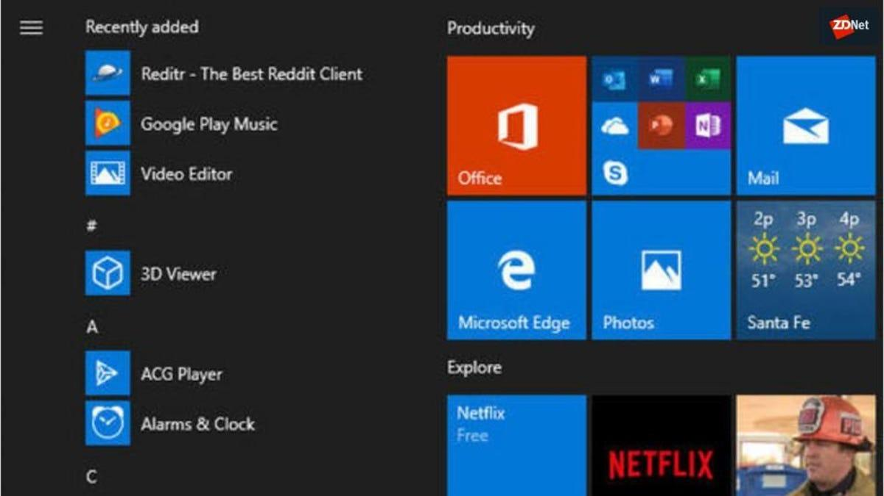
Understanding Windows
Let's talk Windows. Windows went through a rough period during its Windows 8 generation. Microsoft removed the Start menu, forcing users to rely on gestures to find features and launch applications. Microsoft also introduced a limited version of Windows called Windows RT, which only allowed Windows Store apps and didn't run on the Intel platform.

KM-07-KT17: Managing files
Learning Outcome

Question
17
Identify two types of files and give respective purposes
What is File Allocation Table (FAT)?
File Allocation Table (FAT) is a file system that was developed by Microsoft to support small disks and simple folder structures. The file system is named File Allocation Table because it uses a table to track the clusters on a storage volume, as well as how those clusters are linked together through their associated files and directories. Because of the table's important role, the acronym FAT is sometimes used to refer to the table itself, rather than the file system, although it's not uncommon to see it used both ways in a single resource.
The FAT file system got its start with the introduction of MS-DOS, or Microsoft Disk Operating System, and is still in use today, but it has evolved over the years to accommodate growing data volumes. During that time, there have been multiple versions of the file system. The original version was FAT8, followed by FAT12, then FAT16 and finally FAT32. Several variants have also been developed based on the last three versions -- FAT12, FAT16 and FAT32 -- further extending the file system.
The number associated with each FAT version (e.g., FAT16) refers to the number of bits that are used for each entry in the allocation table. For example, an allocation table entry for a FAT16 volume is 16 bits long. However, it's not just the number of entry bits that differentiates the FAT versions. Each version also supports larger volumes and file sizes than its predecessor. Even so, FAT is still limited to small-scale storage compared with more modern file systems. The largest file size FAT32 can support is 4 gigabytes, and the largest volume size is 2 terabytes.
At one time, the FAT file system was used extensively for Windows computers. However, today, most Windows systems use the New Technology File System (NTFS) -- or, to a lesser degree, the Resilient File System (ReFS), which Microsoft introduced in 2012 promising to support greater availability, resiliency and scalability.
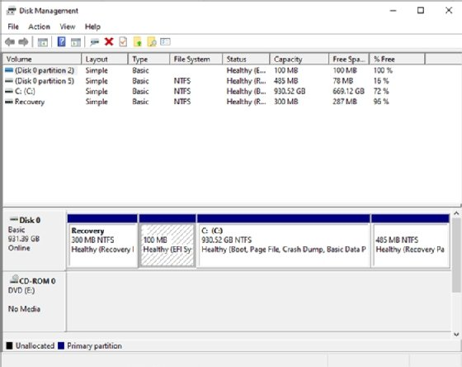
Although Windows 10 and 11 still support FAT, they use NTFS by default, and ReFS to a lesser extent.
Although the FAT system has been superseded on most Windows computers, current Windows editions still support FAT, as do macOS, Linux and Unix. In addition, FAT is still used for floppy disks, USB flash drives and storage media in smaller, portable devices such as digital cameras.
What is the function of File Allocation Table?
FAT plays a pivotal role in facilitating file and directory access on a FAT volume, and is directly integrated into the volume's layout. A FAT volume is organized into multiple sections that follow a prescribed order, starting with the boot sector:
- Boot sector. Stores the information needed by the file system to access the volume, including the volume's layout and file system structure.
- Allocation table region. Stores the primary allocation table, as well as a duplicate of the table that serves as a backup in case the primary table cannot be accessed.
- Root directory. Stores a directory table containing entries that describe the files and folders stored on the volume. Each entry includes information such as name, size, created date and last modified date. An entry also includes the starting cluster number, which corresponds to an entry in the file allocation table. For FAT12 and FAT16, the root directory exists at a specified location on the storage media -- right after the allocation tables -- and has a fixed number of maximum entries. The root directory for FAT32 is maintained in the data region and does not have a fixed number of maximum entries.
- Data region. Stores the actual file and directory data. This area is divided into clusters that make up the bulk of the volume. The clusters are numbered sequentially and correspond to the listings in the allocation table.

KM-07-KT18: Applications utility, troubleshooting, and optimization
Learning Outcome
Question
18
Describe the Optimisation
Optimization (computer science)
In computing, optimization is the process of modifying a system to make some features of it work more efficiently or use fewer resources. For instance, a computer program may be optimized so that it runs faster, or to run with less memory requirements or other resources (see Space-time tradeoff), or to consume less energy. This is a branch of software engineering.
The optimization can have sense at different levels, from the lowest (development of circuits, writing of machine code designed especially for the architecture) up to the highest levels of making of implementation, use or design of algorithms.
The optimization is generally recommended to leave until the end of the process of development, since the premature optimization can introduce new errors (generally more difficult to detect for being of algorithmic nature).
The optimized system may be a single computer program, a collection of computers or even an entire network such as the Internet.

KM-07-KT19: Configuring device drivers
Learning Outcome
Question
19
Explain the considerations for configuring device drivers are reasoned
Installing and Configuring Device Drivers
Devices have changed from being single-function peripherals to complex, multifunction devices, with a large amount of local storage and the ability to run applications. They have evolved from a single type of connection, such as USB, to multi transport devices that support USB, Bluetooth, and WiFi.
Many of today's devices are often integrated and sold with services that are delivered over the Internet, Internet delivery has simplified the delivery mechanism, which means that a computer's ability to recognize and use devices has expanded to cover all possibilities. Microsoft has expanded the list of devices and peripherals that are being tested for compatibility with Windows 8.
The device experience in Windows 8 is designed on existing connectivity protocols and driver models to maximize compatibility with existing devices. The following are areas in Windows 8 that you can use to manage devices:
- The Devices and Printers control panel gives users a single location to find and manage all the devices that connect to a Windows 8-based computer, and provides quick access to device status, product information, and key functions, such as Faxing and scanning. This enhances and simplifies the customer experience with a Windows 8-connected device.
- Device Manager is used to view and update hardware settings and driver software for devices such as internal hard drives, disc drives, sound cards, video or graphics cards, memory, processors, and other internal computer components.
Seamless user experiences begin with the ability to effortlessly connect devices. Additional drivers are retrieved automatically from Windows Update, and when appropriate, users are given an option to download and install additional applications for the device. These components all help reduce support calls and increase customer satisfaction.
Device Drivers in Windows 8
A driver is a small software program that the computer uses to communicate with hardware or devices. It also is specific to an operating system. Without drivers, the hardware that you connect to the computer does not work properly.
In most cases, drivers are part of windows, or you can locate them by navigating to Windows Update, and then checking for updates. If Windows does not have the required driver, look for it on the disc that came with the hardware or device, or on the manufacturer's website.
32-bit and 64-bit Drivers
Windows 8 is available in 32-bit and 64-bit version. Drivers developed for the 32-bit versions do not work with the 64-bit versions, and vice versa. You must make sure that you obtain the appropriate device drivers before you install Windows 8.
Driver Signing
The device drivers that are part of Windows 8 have a Microsoft digital signature that indicates whether a particular driver or file has met a certain level of testing, is stable and reliable, and has not been altered since it was signed digitally. Windows 8 checks for driver's digital signature during installation, and prompts the user if no signature is available.
Note:
The signature file is stored as a .cat file in the same location as the driver file.
Driver Store and Driver Packages
The driver store is the driver repository in Windows 8. A driver package is a set of files that make up a driver. It includes the .inf file, any files that the .inf file references, and the .cat file that contains the digital signature for the device driver. You can preload the driver store with drivers for commonly used peripheral devices. The driver store is located in systemroot\System32\DriverStore.
Installing a driver is a two-stage process. First, you install the driver package into the driver store. You must use administrator credentials to install the driver package into the driver store. The second step is to attach the device and install the driver. A standard user can perform this second step.
During hardware installation, if the appropriate driver is not available, Windows 8 uses Windows Error Reporting to report an unknown device. This enables Original Equipment Manufacturers (OEMs) to work in conjunction with Microsoft to provide additional information to the user, such as a statement of nonsupport for a particular device, or a link to a website with additional support information.
In Windows 8, the Device Metadata System provides an end-to-end process for defining and distributing device metadata packages. These packages contain device experience XML documents that represent the device's properties and functions, together with applications and services that support the device.
Through these XML documents, the Devices and Printers folder and Device Stage present users with an interface that is specific to the device, which the device maker defined.
Windows Online Quality Services (Winqual) validates device-experience XML documents, and then signs device metadata packages. Windows Metadata and Internet Services (WMIS) distributes new or revised device-metadata packages that device makers submit through Winqual.
Windows 8 uses WMIS to discover, index, and match device metadata packages to specific devices that are connected to the computer. Device makers also can distribute device-metadata packages directly to the computer through their own Setup applications.

KM-07-KT20: Networking and wireless connections

Question
20
Discuss networking and wireless connections with reference to types and functionality

Network Devices (Hub, Repeater, Bridge, Switch, Router, Gateways and Brouter)

1. Repeater – A repeater operates at the physical layer. Its job is to regenerate the signal over the same network before the signal becomes too weak or corrupted so as to extend the length to which the signal can be transmitted over the same network. An important point to be noted about repeaters is that they do not amplify the signal. When the signal becomes weak, they copy the signal bit by bit and regenerate it at the original strength. It is a 2 port device.
2. Hub – A hub is basically a multiport repeater. A hub connects multiple wires coming from different branches, for example, the connector in star topology which connects different stations. Hubs cannot filter data, so data packets are sent to all connected devices. In other words, the collision domain of all hosts connected through Hub remains one. Also, they do not have the intelligence to find out the best path for data packets which leads to inefficiencies and wastage.

Types of Hubs
- Active Hub: - These are the hubs that have their own power supply and can clean, boost, and relay the signal along with the network. It serves both as a repeater as well as a wiring centre. These are used to extend the maximum distance between nodes.
- Passive Hub:- These are the hubs that collect wiring from nodes and power supply from the active hub. These hubs relay signals onto the network without cleaning and boosting them and can’t be used to extend the distance between nodes.
- Intelligent Hub:- It works like active hubs and includes remote management capabilities. They also provide flexible data rates to network devices. It also enables an administrator to monitor the traffic passing through the hub and to configure each port in the hub.
3. Bridge – A bridge operates at the data link layer. A bridge is a repeater, with add on the functionality of filtering content by reading the MAC addresses of source and destination. It is also used for interconnecting two LANs working on the same protocol. It has a single input and single output port, thus making it a 2-port device.
Types of Bridges
- Transparent Bridges: - These are the bridge in which the stations are completely unaware of the bridge’s existence i.e., whether or not a bridge is added or deleted from the network, reconfiguration of the stations is unnecessary. These bridges make use of two processes i.e., bridge forwarding and bridge learning.
- Source Routing Bridges:- In these bridges, routing operation is performed by the source station and the frame specifies which route to follow. The host can discover the frame by sending a special frame called the discovery frame, which spreads through the entire network using all possible paths to the destination.
4. Switch – A switch is a multiport bridge with a buffer and a design that can boost its efficiency(a large number of ports imply less traffic) and performance. A switch is a data link layer device. The switch can perform error checking before forwarding data, which makes it very efficient as it does not forward packets that have errors and forward good packets selectively to the correct port only. In other words, the switch divides the collision domain of hosts, but broadcast domain remains the same.
5. Routers – A router is a device like a switch that routes data packets based on their IP addresses. The router is mainly a Network Layer device. Routers normally connect LANs and WANs together and have a dynamically updating routing table based on which they make decisions on routing the data packets. Router divide broadcast domains of hosts connected through it.

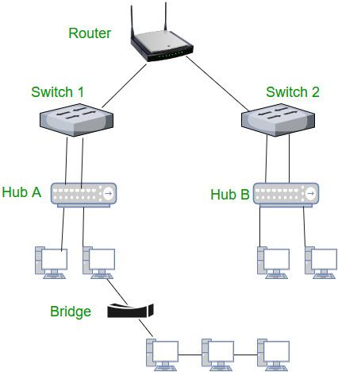

6. Gateway – A gateway, as the name suggests, is a passage to connect two networks together that may work upon different networking models. They basically work as the messenger agents that take data from one system, interpret it, and transfer it to another system. Gateways are also called protocol converters and can operate at any network layer. Gateways are generally more complex than switches or routers. Gateway is also called a protocol converter.
7. Brouter – It is also known as the bridging router is a device that combines features of both bridge and router. It can work either at the data link layer or a network layer. Working as a router, it is capable of routing packets across networks, and working as the bridge, it is capable of filtering local area network traffic.

KM-07-KT21: Recovery
Learning Outcome

Question
21
Describe what is a recovery partition?
Due to the inclusion on their PC by default, many users assume the recovery partition isn’t something they should mess with. In reality, though, it’s completely safe and relatively easy to format the OEM recovery partition and create a recovery partition of your own.
The recovery partition is simply a save of the system’s state when the manufacturer first set up the PC. It usually takes the form of a .wim file that can be accessed through the usual recovery interface. You can create a recovery partition in Windows yourself to replace those files, but it’s usually not a good idea to simply delete the OEM partition without replacing it.
To create a recovery drive in Windows 10, you must first create a Windows recovery image, before preparing the partition and adding it to your boot menu for easy access. If you want to create a full Windows 10 System Image Backup, there is an easier way to do it which does not work to update the recovery partition.
How to Capture a Windows Recovery Image as a WIM file
There’s some preparation required before you create your windows recovery image, though this is reduced if you already keep your OS maintained and up-to-date. First, make sure your PC is fully updated, has the user accounts and software you want to be included, and has the themes/settings you’d prefer. Once complete, boot from Windows installation media by following this guide.
- Open Command Prompt via Windows Installation Media
Once your PC boots, ignore the setup screen and press “Shift + F10” to open the command-line interface.
- (Optional) Initialize networking services
You only need to do this if you want to save your Windows 10 recovery image on a network drive. To do so, type wpeinit and press “Enter”.
- (Optional) Map a network drive for network drive storage
In Command Prompt, enter the following command, replacing ‘Z:’ with your mapped drive, ‘storageserver’ with the server name, and ‘images’ with the name of your shared folder:
net use Z: \\storageserver\images
- Confirm your Windows 10 recovery drive with diskpart
Before you create your Windows recovery image, it’s worth double-checking that you know the correct letter for your Windows drive and to save your image to. In Command prompt, verify this by typing diskpart, then list vol.
You’ll be faced with an output similar to below. In our case, we can look at the size and use our previous knowledge to determine that ‘C’ is our OS/source drive and ‘D’ is the destination we want to save our recovery image to. Be sure to type “exit” to leave diskpart before you continue.

KM-07-KT22: Cloud computing
Learning Outcome
Question
22
Describe cloud computing functionality, benefits and risks
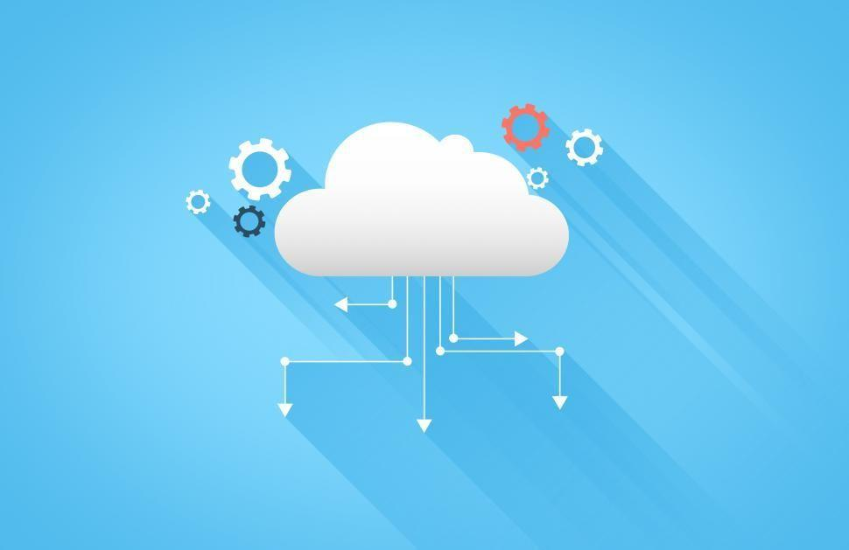
Benefits And Risks Of Cloud Computing
Various aspects of Cloud Computing, its major characteristics, and a comparative analysis between different cloud computing platforms were discussed in the articles Major Characteristics of Cloud Computing and Comparative Analysis of Cloud Platforms respectively. In this article, we’ll learn about the plethora of benefits cloud computing provides as well as the risk aspects of its usage. Each of the pros and cons is described in detail.

Benefits
- Cost Saving and Reduced Investment
- Increase in Scalability
- High Availability and Reliability
- Efficient Collaboration
- Automatic Updates
Cost Saving and Reduced Investment
Cloud Computing has significant hands-on reducing the costs proportionally to the usage of the services and reducing the initial investment for the computing resources. Cloud computing often has a pay-as-you-go model which costs a fraction of the charges and limits the possible excessive cost. The automated cloud capacity is extremely elastic in terms of wisely allocating resources as per the growth or decrease in the customer demand without ever wasting the capacity nor ever having a crisis of insufficient resources. Moreover, the automated cloud capacity will always meet the demand of the customers without wasting the capacity thus providing cost savings. This cost reduction regarded as one of the primary benefits of cloud computing has driven business prospects for this technology adopted by uncountable business enterprises and personal userbases parallelly. Also, not having to invest a huge chuck on servers and computing resources in the initial phase supports the growth for companies that would stay as fixed assets that cannot be dispensed elsewhere for years. Reducing this initial investment is a significant benefit cloud computing has provided in the most accessible way.

Increase in Scalability
The increase in scalability is one of the important benefits of cloud computing. This can be easily illustrated with the ever-changing as elastic customer demand being met by cloud computing technology. The rapid elasticity and automatic triggers that are provided by cloud computing have enabled consumers on assuring that the cloud capacity exceeds the customer demands by a respectable margin in a way it neither leads to the occurrence of hefty billing at the end of the month nor ever slack to meet the consumer demand with resources supply.

When Instagram was bought by Facebook for $1B with only 13 people building and running the company, the world was shaken to witness the value that had been created by such a small group of people. If we dive deeper, the automated features of cloud computing have played a huge role to achieve that feat. Meeting the customer demand for the ever-changing resources need, and with the minimized wasting of capacity and also reducing the need for the expenditure of company resources to predict the customer demand, capacity planning for the business was a monumental feat. This has saved huge charges that would have incurred on the company for unused resources and instead benefitted the increased scalability which has been the driving force for businesses adopting cloud computing.
High Availability and Reliability
As we have discussed Business Continuity in the previous article, Business Continuity and Disaster Recovery, availability and reliability are critical for businesses. Henceforth, the increase in availability and reliability offered by cloud computing has driven its adoption by organizations. We know that availability and reliability can also be offered by the traditional approach to infrastructures. But with Cloud computing, comes in a package with all other characteristics of cloud computing as we’ve discussed in the last article, Major Characteristics of Cloud Computing. Moreover, cloud providers guarantee the associated availability and reliability of the services in the service level agreement (SLA). Companies can adapt and evolve to better respond to the changes of the customer demand as well as mitigate risk for precarious situations that may arise in the future through the availability and reliability provided by cloud computing.

KM-07-KT23: Security fundamentals
Learning Outcome
Question
23
List typical security risks
- Virus: A virus is a malicious, downloadable file that can lay dormant that replicates itself by changing other computer programs with its own code. Once it spreads those files are infected and can spread from one computer to another, and/or corrupt or destroy network data.
- Worms: Can slow down computer networks by eating up bandwidth as well as the slow the efficiency of your computer to process data. A worm is a standalone malware that can propagate and work independently of other files, where a virus needs a host program to spread.
- Trojan: A trojan is a backdoor program that creates an entryway for malicious users to access the computer system by using what looks like a real program, but quickly turns out to be harmful. A trojan virus can delete files, activate other malware hidden on your computer network, such as a virus and steal valuable data.
- Spyware: Much like its name, spyware is a computer virus that gathers information about a person or organization without their express knowledge and may send the information gathered to a third party without the consumer’s consent.
- Adware: Can redirect your search requests to advertising websites and collect marketing data about you in the process so that customized advertisements will be displayed based on your search and buying history.
- Ransomware: This is a type of trojan cyberware that is designed to gain money from the person or organization’s computer on which it is installed by encrypting data so that it is unusable, blocking access to the user’s system.

KM-07-KT24: Introduction to applications
Learning Outcome

Question
24
List various software developments

What is software development?
Software development refers to a set of computer science activities dedicated to the process of creating, designing, deploying and supporting software.
Software itself is the set of instructions or programs that tell a computer what to do. It is independent of hardware and makes computers programmable. There are three basic types:
System software to provide core functions such as operating systems, disk management, utilities, hardware management and other operational necessities.
Programming software to give programmers tools such as text editors, compilers, linkers, debuggers and other tools to create code.
Application software (applications or apps) to help users perform tasks. Office productivity suites, data management software, media players and security programs are examples. Applications also refers to web and mobile applications like those used to shop on Amazon.com, socialize with Facebook or post pictures to Instagram.
A possible fourth type is embedded software. Embedded systems software is used to control machines and devices not typically considered computers — telecommunications networks, cars, industrial robots and more. These devices, and their software, can be connected as part of the Internet of Things (IoT).
Software development is primarily conducted by programmers, software engineers and software developers. These roles interact and overlap, and the dynamics between them vary greatly across development departments and communities.
Programmers, or coders, write source code to program computers for specific tasks like merging databases, processing online orders, routing communications, conducting searches or displaying text and graphics. Programmers typically interpret instructions from software developers and engineers and use programming languages like C++ or Java to carry them out.
Software engineers apply engineering principles to build software and systems to solve problems. They use modelling language and other tools to devise solutions that can often be applied to problems in a general way, as opposed to merely solving for a specific instance or client. Software engineering solutions adhere to the scientific method and must work in the real world, as with bridges or elevators. Their responsibility has grown as products have become increasingly more intelligent with the addition of microprocessors, sensors and software. Not only are more products relying on software for market differentiation, but their software development must be coordinated with the product’s mechanical and electrical development work.
Software developers have a less formal role than engineers and can be closely involved with specific project areas — including writing code. At the same time, they drive the overall software development lifecycle — including working across functional teams to transform requirements into features, managing development teams and processes, and conducting software testing and maintenance.
The work of software development isn’t confined to coders or development teams. Professionals such as scientists, device fabricators and hardware makers also create software code even though they are not primarily software developers. Nor is it confined to traditional information technology industries such as software or semiconductor businesses. In fact, according to the Brookings Institute (link resides outside of ibm.com), those businesses “account for less than half of the companies performing software development.”
An important distinction is custom software development as opposed to commercial software development. Custom software development is the process of designing, creating, deploying and maintaining software for a specific set of users, functions or organizations. In contrast, commercial off-the-shelf software (COTS) is designed for a broad set of requirements, allowing it to be packaged and commercially marketed and distributed.

Steps in the software development process
Developing software typically involves the following steps:
- Selecting a methodology to establish a framework in which the steps of software development are applied. It describes an overall work process or roadmap for the project. Methodologies can include Agile development, DevOps, Rapid Application Development (RAD), Scaled Agile Framework (SAFe), Waterfall and others. (See the glossary.)
- Gathering requirements to understand and document what is required by users and other stakeholders.
- Choosing or building an architecture as the underlying structure within which the software will operate.
- Developing a design around solutions to the problems presented by requirements, often involving process models and storyboards.
- Building a model with a modelling tool that uses a modelling language like SysML or UML to conduct early validation, prototyping and simulation of the design.
- Constructing code in the appropriate programming language. Involves peer and team review to eliminate problems early and produce quality software faster.
- Testing with pre-planned scenarios as part of software design and coding — and conducting performance testing to simulate load testing on the application.
- Managing configuration and defects to understand all the software artifacts (requirements, design, code, test) and build distinct versions of the software. Establish quality assurance priorities and release criteria to address and track defects.
- Deploying the software for use and responding to and resolving user problems.
- Migrating data to the new or updated software from existing applications or data sources if necessary.
- Managing and measuring the project to maintain quality and delivery over the application lifecycle, and to evaluate the development process with models such as the Capability Maturity Model (CMM).
The steps of the software development process fit into application lifecycle management (ALM). The IBM Engineering Management solution is a superset of ALM that enables the management of parallel mechanical, electrical and software development.
- Requirements analysis and specification
- Design and development
- Testing
- Deployment
- Maintenance and support
Software development process steps can be grouped into the phases of the lifecycle, but the importance of the lifecycle is that it recycles to enable continuous improvement. For example, user issues that surface in the maintenance and support phase can become requirements at the beginning of the next cycle.

